

AMIXLED LED BAR 24X4 BATTERY IP65

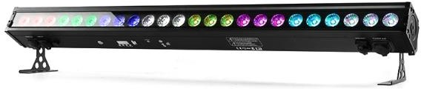

This manual contains important information. Please read before operating fixture.

General safety tips
WARNING!!! To reduce the risk of fire, electric shock, or injury to persons, follow these important safety instructions:
  - non-professionals, not to disassemble the light arbitrarily and lighting accessories inside.
  - rated voltage range: AC110V-120V/60Hz or AC200V-240V / 50HZ (to be selected).
  - not beam irradiate the flammable materials, flammable materials and the lamp should be maintained at least 1M over the distance.
  - lamps used in ambient temperature: -20 ℃ -40 ℃ , the highest temperature of the surface of the lamp: 60 ℃.
  - to keep away from the liquid substance and humid environment.
  - before using the lights must ensure the good grounding, cannot install charging and remove any parts.
  - the installation of lamps, must be fixed screw fasteners with additional security cable and regular inspection.
  - lamps consecutive working hours is not recommended more than 10 hours.
  - should stop using the lights in time when happens unusual conditions during the process.
  - lamp parts of the rotation, external accessories and paste parts should be regular inspected, such as the emergence of loose and rock, should be reinforced in a timely manner to prevent the accident.

Technical Specifications
Power Supply: AC 100-240V/50-60Hz Power consumption:100W
Light source: 24pcs*4w LED RGBW 4in1.
LED feature: Create dazzling effects with 2 /8 zones of individual control. Beam Angle: 25 degrees
Dimmer: 0-100% dimmer Strobe rate:0-24HZ
Working Environment: -20℃-40℃
IP rate: IP65
DMX Channels:6/8/14/50ch
Control Mode: DMX512, Master-slave, Sound, Auto, remote, wireless Control panel: LED display
Power connection: Powercon in out DMX control: 3pin XLR DMX in out Battery type: Lithium Ion
Battery Power: 12V, 27Ah
Battery lifespan: 500 times charging/discharging circles. Battery Charge Time: 6hours (full power)
Battery Life: (all on) 4.5hours, (single Color) 18 hours

On-board Menu layout

Operate menu :
Addr | A001-A512 | DMX Address selection
Chnd | 6/8/14/50ch | Channel selection
Slnd | MAst/d512/SlAU | Master slave selection
Soun | So 0-16 | Sound control effect selection
Soun | Se 99-0 | Sound control sensitivity adjustment
Auto | Au 0- Au16 | Auto effect selection
Auto | SP 0-SP 9 | Auto effect speed adjustment
Colo | Co 1-Co 12 | Color selection
Manu | Red 0-255 | Red dimmer
Manu | Gree 0-255 | Green dimmer
Manu | Blue 0-255 | Blue dimmer
Manu | Whit 0-255 | White dimmer
disp | ds!p | Digital display flip setting
2-4G | On/off | Wireleess on/off
ver | V10 | Current software vertion

DMX Channel Modes

6 Channel
CH | Value | Function
1 | 0-255 | Red 0-100%
2 | 0-255 | Green 0-100%
3 | 0-255 | Blue 0-100%
4 | 0-255 | White 0-100%
5 | 0-255 | Color Chase, See Color Chase Table
6 | 0-255 | Chase Speed Slow To Fast

8 Channel
CH | Value | Function
1 | 0-255 | All dimming
2 | 0-255 | Strobe
3 | 0-255 | Red 0-100%
4 | 0-255 | Green 0-100%
5 | 0-255 | Blue 0-100%
6 | 0-255 | White 0-100%
7 | 0-255 | Color Chase, See Color Chase Table
8 | 0-255 | Chase Speed Slow To Fast

14 Channel
CH | Value | Function
1 | 0-255 | All dimming 1
2 | 0-255 | Strobe
3 | 0-255 | Red 1 0-100%
4 | 0-255 | Green 1 0-100%
5 | 0-255 | Blue 1 0-100%
6 | 0-255 | White1 0-100%
7 | 0-255 | All dimming 2
8 | 0-255 | Strobe
9 | 0-255 | Red 2 0-100%
10 | 0-255 | Green 2 0-100%
11 | 0-255 | Blue 2 0-100%
12 | 0-255 | White 2 0-100%
13 | 0-255 | Color Chase, See Color Chase Table
14 | 0-255 | Chase Speed Slow To Fast

50 Channel
CH | Value | Function
1 | 0-255 | All dimming 1

2 | 0-255 | Strobe1
3 | 0-255 | Red 1 0-100%
4 | 0-255 | Green 1 0-100%
5 | 0-255 | Blue 1 0-100%
6 | 0-255 | White 1 0-100%
7 | 0-255 | All dimming 2
8 | 0-255 | Strobe2
9 | 0-255 | Red 2 0-100%
10 | 0-255 | Green 2 0-100%
11 | 0-255 | Blue 2 0-100%
12 | 0-255 | White 2 0-100%
13 | 0-255 | All dimming 3
14 | 0-255 | Strobe3
15 | 0-255 | Red 3 0-100%
16 | 0-255 | Green 3 0-100%
17 | 0-255 | Blue 3 0-100%
18 | 0-255 | White 3 0-100%
19 | 0-255 | All dimming 4
20 | 0-255 | Strobe4
21 | 0-255 | Red 4 0-100%
22 | 0-255 | Green 4 0-100%
23 | 0-255 | Blue 4 0-100%
24 | 0-255 | White 4 0-100%
25 | 0-255 | All dimming 5
26 | 0-255 | Strobe5
27 | 0-255 | Red 5 0-100%
28 | 0-255 | Green 5 0-100%
29 | 0-255 | Blue 5 0-100%
30 | 0-255 | White 5 0-100%
31 | 0-255 | All dimming 6
32 | 0-255 | Strobe6

33 | 0-255 | Red 6 0-100%
34 | 0-255 | Green 6 0-100%
35 | 0-255 | Blue 6 0-100%
36 | 0-255 | White 6 0-100%
37 | 0-255 | All dimming 7
38 | 0-255 | Strobe7
39 | 0-255 | Red 7 0-100%
40 | 0-255 | Green 7 0-100%
41 | 0-255 | Blue 7 0-100%
42 | 0-255 | White 7 0-100%
43 | 0-255 | All dimming 8
44 | 0-255 | Strobe8
45 | 0-255 | Red 8 0-100%
46 | 0-255 | Green 8 0-100%
47 | 0-255 | Blue 8 0-100%
48 | 0-255 | White 8 0-100%
49 | 0-255 | Color Chase, See Color Chase Table
50 | 0-255 | Chase Speed Slow To Fast

Color chase table
Color chase | Value | Function
Color chase | 000-007 | No function
Color chase | 008-022 | Color chase 01
Color chase | 023-037 | Color chase 02
Color chase | 038-052 | Color chase 03
Color chase | 053-067 | Color chase 04
Color chase | 068-082 | Color chase 05
Color chase | 083-097 | Color chase 06
Color chase | 098-112 | Color chase 07
Color chase | 113-127 | Color chase 08

 | 128-142 | Color chase 09
 | 143-157 | Color chase 10
 | 157-172 | Color chase 11
 | 173-187 | Color chase 12
 | 188-202 | Color chase 13
 | 203-217 | Color chase 14
 | 218-232 | Color chase 15
 | 233-247 | Color chase 16
 | 248-255 | Sound effect 1-16

Installing the fixture
Please fasten the fixture clamp before hanging. The clamp can be fastened by the little hole in the middle of the bracket, then tie with a safety belt. The loading capacity of the safety belt should be 10 times than the weight of the fixture itself.

DMX protocol connection
Please connect XLR-XLR control wire with every light from the output of DMX.
XLR connection:
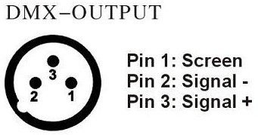
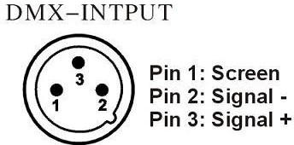
ATTENTION: Please do remember to connect one circle circuit plug on the output signal of last equipment. And this circle circuit plug was connected a 120ohm resistance between terminals 2 and 3 of the CANON plug, connect

this circle circuit plug can avoid the signal flash phenomena of signal DMX512 during the transmission.
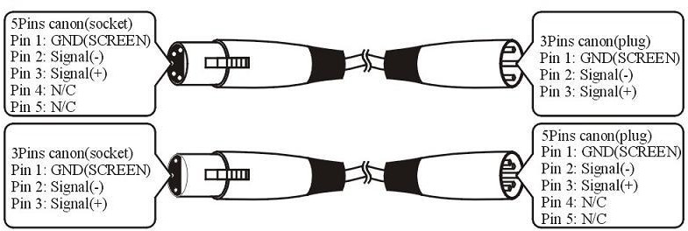

Maintenance/Troubleshooting
Problems | Check list | Trouble Shooting
The fixture does not work. | - If your power as same as the input of the machine.  - If the fuse was broken. | - Make sure the voltage.  - Replace the same fuse.
LED dimmed. | If your power us same as the input of the machine | Make sure the voltage input.
No DMX  input. | - If the polarity is opposite in the DMX controller.  - If it is in DMX mode.  - If there are 2 Master in a loop. | - Correct the DMX polarity.  - Change to the DMX mode.  - Set one piece into  Slave mode.
Bar Light works abnormality | - Check if the serial is correct on the Par Light display | - Set the right serial No on the single Par  Light


Warranty Card
Name
Model
Production Purchase
End User Company Name:
Add:
Sale Store
Link man: Tel:
Stamp

Description: These must be truthfully fill, seal by the end-user and point-of-sale, or else the warranty will not work (warranty period and terms, see the following)
warranty period：one year since purchase warranty terms：1、If fail when using the product in
normal state, you can made under the provisions of the warranty, show the warranty card and purchase bills(copy), and enjoy free maintenance service in a specific service center or the manufacturer.
- The following will be the implementation of paid service:
  - Without the effective warranty card
  - There’s blank, alter and no point-of-sale name
  - Fail caused by power supply
  - Fail caused by transportation or unloading
  - Fail caused by not operate by manual
  - Fail caused by disassemble without unauthorized
  - Fail caused by using the unauthorized control system

Note:
Based on our company continue to improve the product, the statement containing data may have changed, and without any notice. Company retains its right to change specifications related when product is improved. Thanks for your understanding.

